Part 3 – SQL Exploration & Analytics
Write and save eight SQL views or queries that demonstrate:
1. Single-table aggregation (GROUP BY)
2. Multi-table join (INNER)
3. Outer join or sub-query
4. Window/analytic function
5. CTE or recursive query
6. Derived metric updated with ALTER TABLE + UPDATE
7. Index-usage demonstration with EXPLAIN (before/after)
8. Creation of a materialized view or standard view + refresh strategy

- Single-table aggregation (GROUP BY)
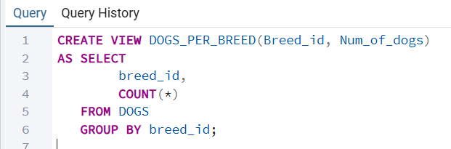
Interpretation: This view groups tuples from the base table DOGS by breed_id and computes the number of dogs belonging to each breed. It serves as a virtual summary table that eliminates the need to repeat the GROUP BY aggregation in future queries. Analysts can now retrieve breed-level statistics directly from this view as if it were a base relation.

- Multi-table join (INNER)
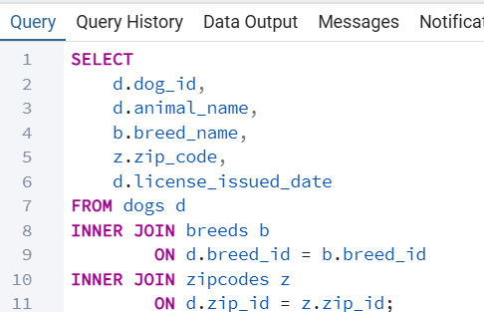
Interpretation: This query demonstrates an INNER JOIN across three related tables: DOGS, BREEDS, and ZIPCODES. It enriches each dog record by replacing foreign key identifiers with readable breed names and ZIP codes, producing a unified and meaningful dataset. This multi-table join shows how normalized relations can be combined to support practical reporting and analytical tasks.

- Outer join or sub-query
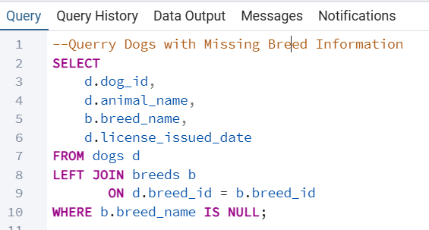
Interpretation: This query uses a LEFT OUTER JOIN to identify dog records that have no matching breed entry in the BREEDS lookup table. The LEFT JOIN preserves all rows from the DOGS table and inserts NULL values when no corresponding breed exists, allowing analysts to detect missing or inconsistent reference data. This example demonstrates how outer joins support data-quality checks and highlight integrity issues in a relational schema.
- Window/analytic function
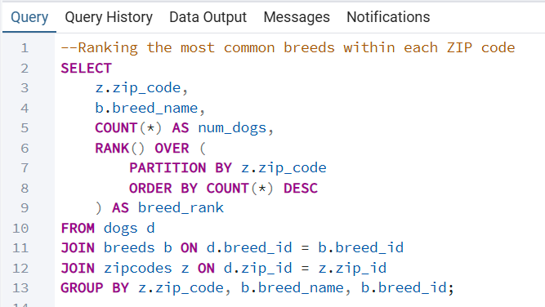
Interpretation: This query uses the analytic function RANK() with a PARTITION BY clause to rank dog breeds within each ZIP code based on their frequency. The window function evaluates the ranking after aggregation, without collapsing ZIP codes into a single group. This demonstrates how analytic queries can reveal local patterns such as the most common breed per ZIP while preserving detailed row-level structure.
- CTE or recursive query
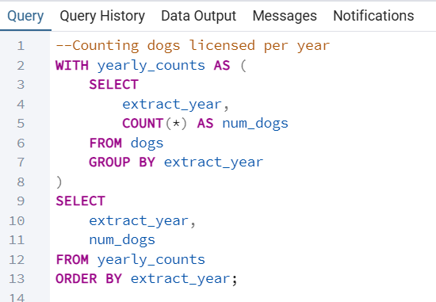
Interpretation: This query uses a Common Table Expression to separate the logic of computing dog counts per year from the final retrieval step. The CTE yearly_counts performs the aggregation, while the outer query selects from the intermediate result as if it were a temporary view. This structure improves readability and breaks a complex task into smaller, simpler, reusable parts when working with multi-step analytical queries.
- Derived metric updated with ALTER TABLE + UPDATE
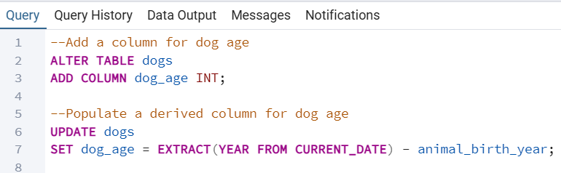
Interpretation: This example demonstrates how to add a derived metric to an existing table using ALTER TABLE followed by UPDATE. The new column dog_age is computed by subtracting each dog’s birth year from the current calendar year, creating a meaningful attribute for age-based analysis. This approach shows how derived metrics can be incorporated into a relational schema to support richer analytical queries.
- Index-usage demonstration with EXPLAIN (before/after)
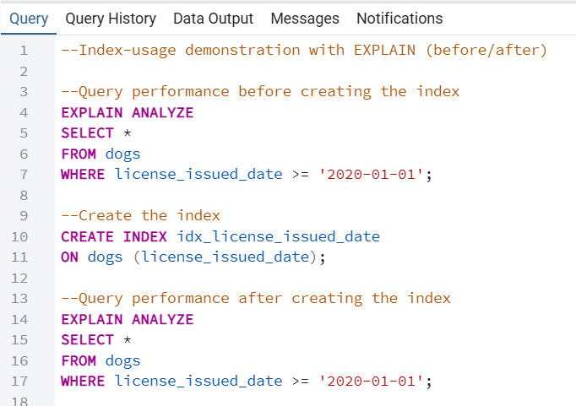
Interpretation: This demonstration compares a SELECT query run before and after creating an index on the license_issued_date column of the DOGS table. The first EXPLAIN ANALYZE typically shows a sequential scan, indicating that PostgreSQL must read the entire table to evaluate the filter condition. After adding the index, the query planner switches to an index-based scan, lowering query cost and improving performance, which illustrates the effectiveness of indexing frequently filtered columns.
- Creation of a materialized view or standard view + refresh strategy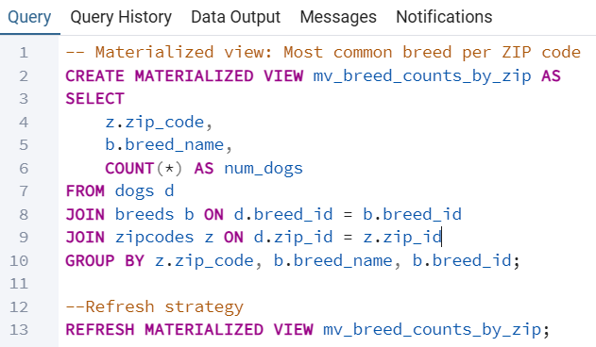
Interpretation: This materialized view stores precomputed dog counts per breed and ZIP code, improving performance for repeated analytical queries. Because the data is materialized physically, it must be refreshed when new dog records are loaded into the database. The REFRESH MATERIALIZED VIEW command regenerates the stored results, ensuring that the view remains synchronized with updates to the underlying tables.

